**SMART WATER FOUNTAINS**

A smart water fountain in IoT can offer several benefits, including water conservation, efficient maintenance, and improved user experience. However, it also presents challenges that need to be addressed for effective implementation. Here are some common problems and potential solutions for a smart water fountain in IoT:

**Problems:**

1. **Water Conservation:**

**Problem:** Traditional water fountains can be wasteful, especially in public areas where they may run continuously.

**Solution:** Implement IoT sensors to detect user presence and activate the fountain only when someone approaches. Use flow sensors to regulate water usage and avoid unnecessary waste.

1. **Water Quality:**

**Problem:** Ensuring the water is clean and safe for consumption is essential in public spaces.

**Solution:** Integrate water quality sensors to monitor water conditions. These sensors can detect contaminants or unusual changes in water quality and trigger maintenance alerts when necessary.

1. **Maintenance and Repairs:**

**Problem:** Malfunctions, clogs, or wear and tear can disrupt the functionality of a water fountain.

**Solution:** Utilize IoT sensors to monitor the fountain's operational status. Implement predictive maintenance algorithms that analyze data from sensors to predict potential issues, enabling timely repairs and maintenance.

1. **Water Usage Monitoring:**

**Problem:** Monitoring water usage and ensuring compliance with water conservation regulations can be challenging.

**Solution:** Use IoT-based water meters to measure and track water consumption. This data can be used for billing purposes and to assess the environmental impact of the fountain.

1. **User Experience:**

**Problem:** Inconsistent water pressure, temperature, or cleanliness can lead to a poor user experience.

**Solution:** Implement IoT controls to adjust water pressure and temperature based on user preferences. Use sensors to detect the water's cleanliness and trigger filtration or treatment processes when needed.

1. **Energy Efficiency:**

**Problem:** Running water fountains can consume a significant amount of energy, especially in high-traffic areas.

**Solution:** Optimize energy usage by using energy-efficient pumps and sensors that activate the fountain only when needed. Consider using renewable energy sources for power.

1. **User Interface:**

**Problem:** Users may struggle to interact with traditional water fountains effectively.

**Solution:** Implement touchless user interfaces, such as motion sensors or mobile apps, to activate and control the fountain. Provide clear instructions for users.

1. **Data Security and Privacy:**

**Problem:** Collecting data from IoT sensors can raise concerns about data security and privacy.

**Solution:** Encrypt data in transit and at rest, secure access to the IoT system, and anonymize any data that may relate to user behavior.

1. **Costs and ROI:**

**Problem**: Implementing IoT-based smart fountains can involve significant upfront costs.

**Solution:** Calculate the return on investment (ROI) by considering factors like water savings, reduced maintenance costs, and improved user satisfaction. Seek grants or partnerships to offset initial expenses.

1. **Integration and Interoperability:**

**Problem:** Ensuring that the smart water fountain system integrates with existing infrastructure and IoT platforms can be complex.

**Solution:** Use standardized communication protocols and open APIs to enable interoperability with other IoT devices and management systems.

# Problem Definition and Design Thinking

In this part you will need to understand the problem statement and create a document on what have you understood and how will you proceed ahead with solving the problem. Please think on a design and present in form of a document.

**Project Definition:** The project aims to enhance public water fountains by implementing IoT sensors to control water flow and detect malfunctions. The primary objective is to provide real-time information about water fountain status to residents through a public platform. This project includes defining objectives, designing the IoT sensor system, developing the water fountain status platform, and integrating them using IoT technology and Python.

**Design Thinking:**

1. Project Objectives: Define objectives such as real-time water fountain monitoring, efficient water usage, malfunction detection, and resident awareness.
2. IoT Sensor Design: Plan the deployment of IoT sensors (e.g., flow rate sensors, pressure sensors) in public water fountains.
3. Real-Time Transit Information Platform: Design a mobile app interface that displays real-time parking availability to users.
4. Integration Approach: Determine how IoT sensors will send data to the water fountain status platform.

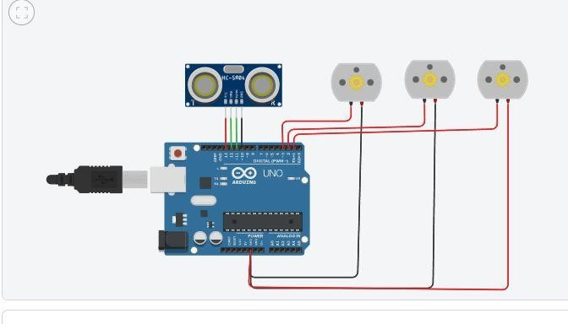

**Fig:** smart water fountain using ultrasonic sensor

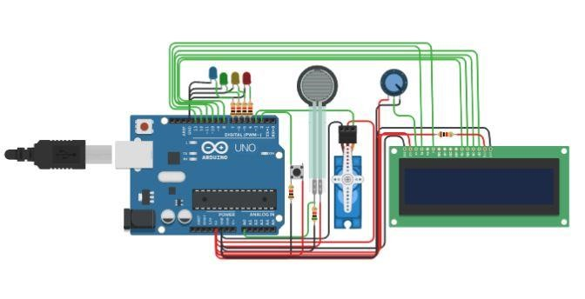

**Fig:** water flow control using sensor